What are user stories?

A user story is a small, self-contained unit of development work designed to accomplish a specific goal within a product. A user story is usually written from the user’s perspective and follows the format:

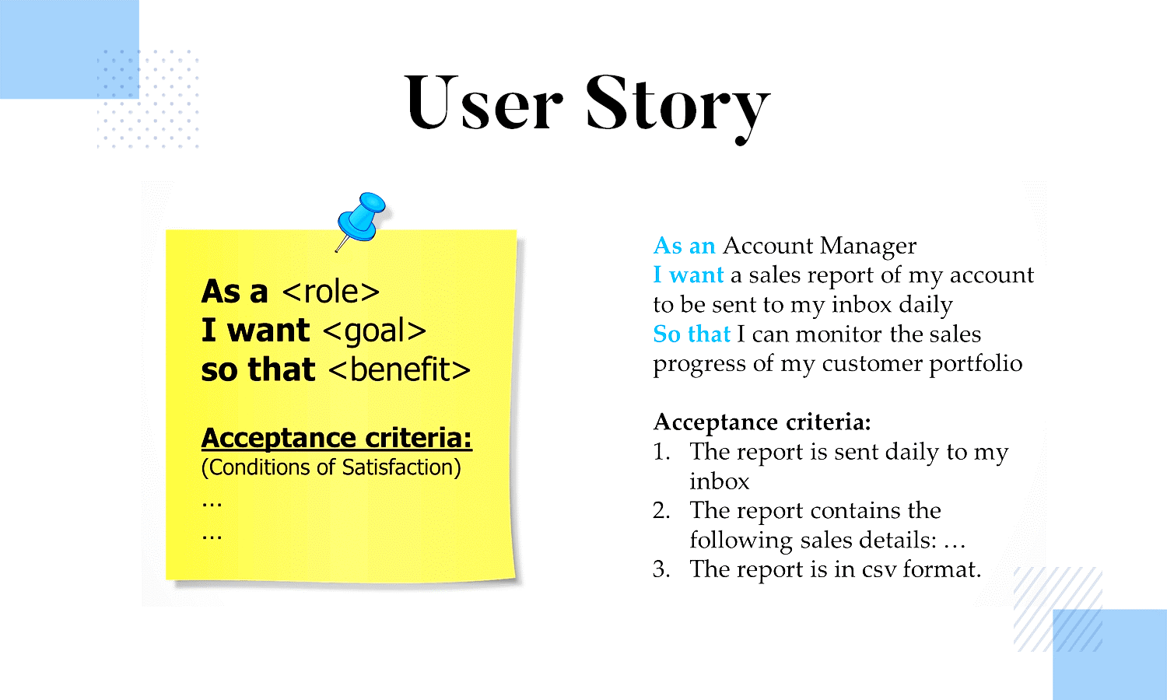

Stories for All Actors (Guest, Registered Users, Admin [Authorized/Unauthorized])

1. As an actor, I want to see the website on multiple browsers.
2. As an actor, I want to view the products by applying filters (by category, by price, by name, etc) so that I can search efficiently.
3. As an actor, I want to view the products by applying combinations of multiple filters (by category & by price, by name & by rating, etc) so that I can search efficiently.
4. As an actor I can view ratings and reviews given by other users so that I can know product quality.
5. As an actor, I want to view a specific product so that I can view further details.

Stories for these actors Admins/Registered Users

1. As a registered user, I want to receive a unique account activation link on my email so that I can activate my account.
2. As a registered user, I want to activate my account for verification and security.
3. As a registered user, I want to log in to my account so that I can use its services like order products, add to cart, manage account, etc.
4. As I registered user, I want to receive an email of every new login from my account to keep a track of my activity.
5. As an actor, I want to view my account details so that I can verify or update my account details.
6. As an actor, I want to update my account details so that I can update or correct them if required.
7. As an actor, I want to activate 2-factor authentication so that I can make my account more secure and nobody else can access my account.
8. As an actor, I want to receive an otp on my registered email so that I can verify my self while login if 2-factor authentication is enabled.
9. As an actor, I want to receive an email of suspicious activity when 2-factor authentication is enabled and entered wrong otp so that I can change my password to secure my account.
10. As an actor, I want to deactivate 2-factor authentication so that I can directly login with my email id and password.
11. As an actor, I want to delete my account for my personal reasons.
12. As an actor, I want to see my name on every page so that I can assure I am still logged in.
13. As an actor, I want to log out of my account from any device if I want to so that I can secure my account.

Stories for Admin (Authorized/Unauthorized) Users

Stories for Guest Users

1. As a guest user, I want to sign up for an account on the website to use its services like order products, add to cart, etc.
2. As a guest user, I want to check out the contact information and get the queries cleared.
3. As a guest user, I want to activate the newsletter service so that I can get updates of exciting deals and sales on different products.
4. As a user, I want to view contact details so that I can send my queries.

Stories for Registered Users

1. As a registered user, I want to view my interested category products so that I can view my favorite products.
2. As a registered user I want to order any product so that I can buy them.
3. As a registered user I want to add products to my cart so that I can directly place an order from my cart later.
4. As a registered user, I want to update the quantity of products from my cart so that I can manage my cart.
5. As a registered user, I want to delete products from my cart so that I can remove unwanted products if I added them by mistake.
6. As a registered user, I want to order single/multiple products from my cart so that I can buy them easily.
7. As a registered user, I want to pay securely for the orders I placed so that my orders are confirmed.
8. As a registered user, I want to receive an order confirmation email with an order id on my registered email id so that I can keep track of my order details.
9. As a registered user, I want to receive emails whenever my order status gets updated so that I can keep track of my order and its delivery date.
10. As a registered user, I want to view my orders so that I can keep track of my orders.
11. As a registered user, I want to cancel or return a product due to some personal reasons or if product quality is poor.
12. As a registered user, I want to rate and review products that I have purchased and received so that other users can know what actually they are buying.
13. As a registered user, I want to receive newsletter service so that I can get updates of exciting deals and sales on different products.
14. As a user, I want to view contact details so that I can send my queries.